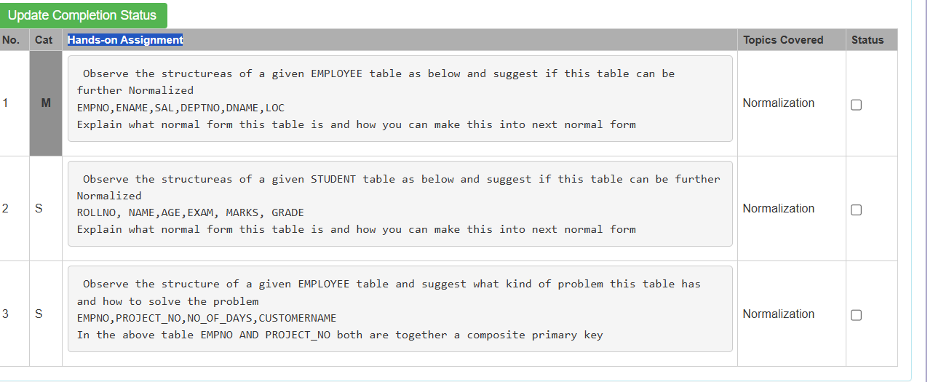
Problem
Observe the structure of the given EMPLOYEE table as shown below and suggest whether this table can be further normalized.
EMPLOYEE Table
EMPNO | ENAME | SAL | DEPTNO | DNAME | LOC
101 | Raj | 25000 | 10 | Sales | Delhi
102 | Ram | 30000 | 20 | HR | Mumbai

Query
Employee Table
CREATE TABLE Employee (
EMPNO INT PRIMARY KEY,
ENAME VARCHAR(30),
SAL NUMBER(8,2),
DEPTNO INT
);
INSERT INTO Employee VALUES
(101,'Raj',25000,10),
(102,'Ram',30000,20);
SELECT * FROM Employee;
Department Table
CREATE TABLE Department (
DEPTNO INT PRIMARY KEY,
DNAME VARCHAR(30),
LOC VARCHAR(30)
);
INSERT INTO Department VALUES
(10,'Sales','Delhi'),
(20,'HR','Mumbai');
SELECT * FROM Department;
Output
Employee Table
EMPNO | ENAME | SAL | DEPTNO
101 | Raj | 25000 | 10
102 | Ram | 30000 | 20
Department Table
DEPTNO | DNAME | LOC
10 | Sales | Delhi
20 | HR | Mumbai

Problem 2
Observe the structure of the given STUDENT table as shown below and suggest whether this table can be further normalized.
STUDENT Table
ROLLNO | NAME | AGE | EXAM | MARKS | GRADE
101 | Raj | 20 | DBMS | 85 | A
102 | Ram | 21 | Java | 72 | B

Student Table
CREATE TABLE Student (
ROLLNO INT PRIMARY KEY,
NAME VARCHAR(30),
AGE INT
);
INSERT INTO Student VALUES
(101,'Raj',20),
(102,'Ram',21);
SELECT * FROM Student;
Exam_Result Table
CREATE TABLE Exam_Result (
ROLLNO INT,
EXAM VARCHAR(30),
MARKS INT
);
INSERT INTO Exam_Result VALUES
(101,'DBMS',85),
(102,'Java',72);
SELECT * FROM Exam_Result;
Grade Table
CREATE TABLE Grade (
MARKS INT PRIMARY KEY,
GRADE CHAR(2)
);
INSERT INTO Grade VALUES
(85,'A'),
(72,'B');
SELECT * FROM Grade;

Output
Student Table
ROLLNO | NAME | AGE
101 | Raj | 20
102 | Ram | 21

Exam_Result Table
ROLLNO | EXAM | MARKS
101 | DBMS | 85
102 | Java | 72

Grade Table
MARKS | GRADE
85 | A
72 | B

Problem 3
Observe the structure of the given EMPLOYEE table as shown below and suggest what kind of problem this table has and how to solve it.
EMPLOYEE_PROJECT Table
EMPNO | PROJECT_NO | NO_OF_DAYS | CUSTOMERNAME
101 | P101 | 25 | ABC Ltd
102 | P102 | 30 | XYZ Pvt Ltd

Employee_Project Table
CREATE TABLE Employee_Project (
EMPNO INT,
PROJECT_NO VARCHAR(10),
NO_OF_DAYS INT,
PRIMARY KEY (EMPNO, PROJECT_NO)
);
INSERT INTO Employee_Project VALUES
(101,'P101',25),
(102,'P102',30);
SELECT * FROM Employee_Project;
Project Table
CREATE TABLE Project (
PROJECT_NO VARCHAR(10) PRIMARY KEY,
CUSTOMERNAME VARCHAR(30)
);
INSERT INTO Project VALUES
('P101','ABC Ltd'),
('P102','XYZ Pvt Ltd');
SELECT * FROM Project;
Employee_Project Table
EMPNO | PROJECT_NO | NO_OF_DAYS
101 | P101 | 25
102 | P102 | 30
Project Table
PROJECT_NO | CUSTOMERNAME
P101 | ABC Ltd
P102 | XYZ Pvt Ltd

